Hong Kong Exchanges and Clearing Limited and The Stock Exchange of Hong Kong Limited take no responsibility for the contents of this announcement, make no representation as to its accuracy or completeness and expressly disclaim any liability whatsoever for any loss howsoever arising from or in reliance upon the whole or any part of the contents of this announcement.

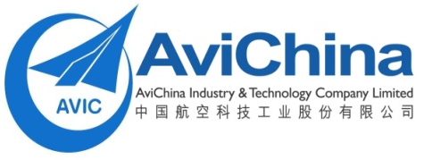

中國航空科技工業股份有限公司
AviChina Industry & Technology Company Limited*

(A joint stock limited company incorporated in the People’s Republic of China with limited liability)

(Stock Code: 2357)

CHANGE OF SUPERVISORY COMMITTEE

The board of directors (the “Board”) of AviChina Industry & Technology Company Limited (the “Company”) announces that Mr. Li Yuhai and Mr. Tang Jianguo have resigned from their positions as the employee representative supervisors of the Company due to their respective work reallocations.
Mr. Li Yuhai and Mr. Tang Jianguo have confirmed that they have no disagreement with the Company, the Board and the Supervisory Committee of the Company and there is no matter in relation to their resignations that needs to be brought to the attention of the shareholders, the Board and the Supervisory Committee of the Company.

By Order of the Board
AviChina Industry & Technology Company Limited*
Yan Lingxi
Company Secretary

Hong Kong, 30 December 2011

As at the date of this announcement, the board of directors of the Company comprises executive directors Mr. Lin Zuoming, Mr. Tan Ruisong and Mr. Wu Xiandong and non-executive directors Mr. Gu Huizhong, Mr. Xu Zhanbin, Mr. Geng Ruguang, Mr. Zhang Xinguo, Mr. Gao Jianshe, Mr. Li Fangyong, Mr. Chen Yuanxian, Mr. Wang Yong, Mr. Maurice Savart as well as independent non-executive directors Mr. Guo Chongqing, Mr. Li Xianzong and Mr. Lau Chung Man, Louis.
* For identification purposes only.

